41068 Robotics Studio 1

Spot Search and Rescue

Sprint Number: 1

Version Number: 1

Date: 20-08-2024

Team K-10

|  |  |  |
| --- | --- | --- |
| Student Number | Full Name | Email |
| 24443691 | James Silsby | james.silsby@student.uts.edu.au |
| 14163885 | Joseph Tarbath | joseph.a.tarbath@hotmail.com |
| 24459594 | Connor Williams | connor.a.williams@student.uts.edu.au |
| 24502825 | Jet Webb | jet.t.webb@student.uts.edu.au |
| 24439287 | Tamsyn Crangle | tamsyn.m.crangle@student.uts.edu.au |

Contents

Project Description 3

Sprint 1 4

SLO 1.1 Communicating with the stakeholder 4

SLO 1.2 Identifying and agreeing on the priorities, goals, and system requirements 4

SLO 2.1 Problem Statement 5

SLO 2.2 Functional requirements and design parameters of project 5

SLO 2.3 Technical Statement 5

SLO 2.4 Design Objectives 6

SLO 2.5 Evaluation Criteria 7

SLO 2.6 Timeline for the Sprint 1 7

SLO 3.1 Configuring the system 7

SLO 3.2 Setting up a simple indoor office environment in Gazebo 7

SLO 3.3 Design and Develop a Subscriber/Publisher 8

SLO 4.1 Time Management 9

SLO 4.2 Communication Skills 9

Appendix 10

Client Meeting 1 Minutes 10

# Project Description

The aim of this project is to develop an autonomous search and rescue mapping system, using Spot, the robot dog, to assist first responders in hazardous urban earthquake zones by identifying gas hazards as well as key areas of interest for the responders. The primary goal is to map a safe and efficient route to be taken by responders that leads to areas of interest where potential casualties may be. We plan to identify hazardous gasses commonly found in disaster zones (CO, CO2 and CH4), using a gas sensor and a combination of infrared, sound and RGB-D sensors to identify potential people trapped through usage of thermal, visual and audio data. Spot will autonomously plan and execute two stage room sweeps to enhance the accuracy of the identification systems.

The project will utilise Gazebo simulation software and a TurtleBot 3 to simulate the actions of Spot. We will use a simulated urban earthquake disaster zone with areas of each gas type and two hidden people to test our systems capability. Through this testing, we aim to test the robot on a TurtleBot 3 as the end goal for this project.

# Sprint 1

## SLO 1.1 Communicating with the stakeholder

Meeting date: 16/08/2024

Stakeholder name: Sangmin Song

Discussed the project situation, types of sensors that will be used, and how we are going to simulate the code.

Also discussed goals for the project which are listed below

1. Gas leak situation

2. Sound Sensing

3. Finding a hidden person

4. Report back a safe path

More details can be found in Appendix A – Client Meeting Minutes

## SLO 1.2 Identifying and agreeing on the priorities, goals, and system requirements

Our team wanted to design a robot that could detect and save people from a variety of natural disasters. We wanted this to be versatile so that we could help with floods, fires, earthquakes, and others. After discussions with our stakeholder, we decided to prioritise the most feasible of these situations, being post-earthquake support. We also determined that spot is incapable of digging out trapped people, hence we settled on the detection of points of interest. With these things in mind, our primary goal is to have our search and rescue robot, spot, explore earthquake affected areas and determine locations it believes to have trapped people.

Our priorities to achieve this goal are to incorporate navigation and mapping using SLAM, implement sensors including audio, hazardous gas, thermal, and an integrated system to combine, process and determine areas that are most likely to contain trapped people. These areas will then be transmitted to the master control panel for further investigation by rescue teams. These have been determined to be vital functions to provide a successful search and rescue robot, with other functionalities and features being wanted but not essential at this stage. As the project continues our current priority and focus will shift, however, these points will remain the most important.

## SLO 2.1 Problem Statement

In the aftermath of an earthquake in an urban area, first responders are exposed to a highly dangerous environment including hazards that cannot be seen with the naked eye such as natural gas, this slows down the response time reach to casualties, whilst they make the area safer for the responders. As the casualties may be critically injured, this delay can be the difference between life and death. This opens a design opportunity to develop a system using the Spot robot to enter these hazardous areas and create a map for the first responders, highlight key areas such as pockets of natural gas, and potential casualties through the use of visuals, infrared, and sound, using this data to create a map for the first responders to locate and rescue the casualties.

## SLO 2.2 Functional requirements and design parameters of project

|  |  |
| --- | --- |
| **Functional Requirements** | **Design Parameters** |
| The simulation must have gas leak detection | The system must be able to detect when, CO, CO2, CH4, reach a level that is unsafe for humans. It also must detect the location of this leak within 5 minutes. |
| The simulation must cover four separate rooms | The system must be able to navigate four separate rooms with a success rate of 90% |
| The simulation must investigate blind spots | The system must investigate over 90% of blind spots. |
| The simulation must differentiate between a person and the environment | The system must be able to differentiate between a person and the environment with 85% certainty. |
| The simulation must identify sound from a person | The system must be able to distinguish between sound from a person and the environment with 80% accuracy. |
| The simulation must identify safe route to casualty | The system must be able to create a path to a casualty that is possible to be taken by the system. It must not be a path that significantly damages the system. |

## SLO 2.3 Technical Statement

The team has decided to simulate an urban earthquake environment in Gazebo because of the flexibility in creating 3D environments. Custom models can be created to simulate a variety of areas, obstacles, and challenges. Moreover, the team is familiar with using the software gazebo, having used it in previous subjects. This knowledge will help the team to make an intricate and well-crafted simulation. Furthermore, UTS only has access to one spot robot across all engineering classes which makes accessing the robot difficult. Therefore, a simulation using a turtle bot will be a faster and more efficient way to test and run code.

The choice of sensors was first discussed within the team and then discussed with the client. The main sensors being used are an RGB-D camera, microphone, gas sensor and thermal camera. The RGB-D camera was chosen because it is part of the spot robot. The microphone, gas sensor and thermal sensors have been chosen because they can be added to the gazebo simulation. Furthermore, they will be required to complete the tasks set by the client.

## SLO 2.4 Design Objectives

|  |  |
| --- | --- |
| Gas leak detection | The sensor will be able to detect specific gases CO, CO2 and CH4 (natural gas). The concentration of these gases will be reported back to the user and location marked. The goal of gas detection will be able to successfully locate areas of hazards gas. |
| Simulation area of 4 rooms | The area will consist of 4 different rooms with different sizes and obstacles. In one of the rooms there will be a hidden person which the turtle bot will identify. |
| Investigate blind spots | The turtle bot can navigate the terrain and map its location as it travels into the disaster area. |
| Differentiate between a person and an object | The turtle bot will use a range of sensors including an RGB-D camera, thermal camera, and microphone. Using a combination of those sensors the turtle bot will be able to identify a hidden person. It will also be able to differentiate between a person and the surrounding area. Once a person has been found the location will be flagged and sent back to the user. |
| Identify sound from a person | The turtle bot will utilise a microphone to detect and identify human-generated sounds, such as speech, footsteps, or other vocalisations. This capability will enable the system to distinguish these sounds from ambient noise, ensuring accurate identification of a person's presence through auditory cues. |
| Identify safe route to casualty | During the autonomous navigation of the turtle bot a safe route will be calculated and sent back to a user. The route will be a series of waypoints. Using the RGB-D camera, pictures will be sent back to the user to visualise the waypoints. The goal of the design is to be able to share the safest route to a user. |
| Demonstrate hardware | The information received from the sensor in the system should send the gas data, sound data, identification data and waypoints back to a terminal. The data should be displayed in an easy-to-read way. |

## SLO 2.5 Evaluation Criteria

|  |  |
| --- | --- |
| Criteria | Description |
| Gas Leak Detection | The TurtleBot should be able to detect the following gasses within an error margin of ±10%:   * CO * CO2 * Natural Gas |
| Simulation Area | The TurtleBot should be able to investigate at least 4 different rooms in their entirety.   * Blind spots should be identified and investigated without additional user input. |
| Human Detection | The TurtleBot should be able to positively identify a human with an accuracy of 75%. |
| Sound Detection | The TurtleBot should use sound to identify potential hazards and humans. |
| Safe Routing | The TurtleBot should identify safe routes for casualty extraction, minimising risk to self and humans. |

## SLO 2.6 Timeline for the Sprint 1

## SLO 3.1 Configuring the system

I decided to set up my Linux environment as a bootable external SSD as I had a small SSD that was not in use, and it will allow me to more easily complete work and troubleshoot problems as I am familiar with Ubuntu’s graphical user interface. I was considering using a virtual machine, however, as my laptop is relatively old, running Linux through a virtual machine on windows causes significant stuttering and crashes. To configure my system I followed the guide on canvas and made minor quality of life adjustments to my Linux install such as disabling mouse acceleration, installing terminator, and a variety of other convenient programs and settings.

## SLO 3.2 Setting up a simple indoor office environment in Gazebo

Initially I was having trouble running the house world on Gazebo. I attempted rebuilding the ROS workspace using colcon build, however, it did not fix it. After some research I found that the issue was that it simply needed a long time to load everything in on the first run. To resolve this issue, I left Gazebo loading on my desktop instead of my laptop for the first run after removing the build folder and doing a full rebuild.

I also initially had trouble creating a package as I was getting many errors while trying to run my code that didn’t seem relevant to the code I had written. After some research online I found out that the issue was ROS has other configurable files that need to be manually configured after creating the package such as package.xml and setup.py. After I made the changes suggested online to these files such as adding the name of my code file, the ros2 run command begun to work as expected.

Below is a simple indoor office environment setup I created within Gazebo that includes the TurtleBot.

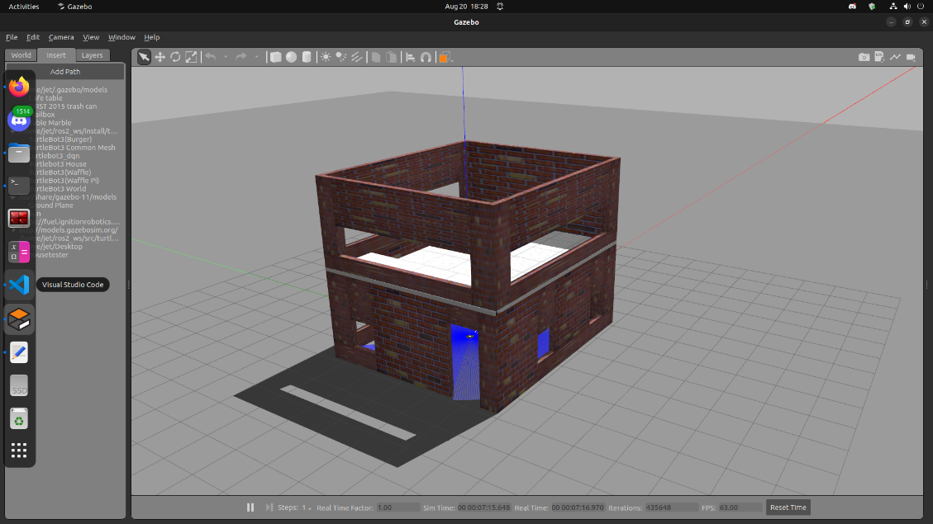

## SLO 3.3 Design and Develop a Subscriber/Publisher

I used NumPy’s array slicing through *scan_msg.ranges[::self.n]* in order to only keep every nth value of the array and remove the rest, I placed these values within a new LaserScan message. The code then multiplies the angle between each scan by n so that the scans are placed in the correct location, this needs to be done as through removing a group of points, the angle between the remaining points will increase. In addition, time_increment is multiplied by the same amount so that the time between each scan is also corrected.

In order to change the value of n without having to restart the simulation and manually modify the code, I created a subscriber that listen for an Int8 and changes n to whatever value is read. To utilise this feature, an integer can simply be published to the topic set_n using ros2 topic pub through the terminal in order to change the sequence of scans.

## SLO 4.1 Time Management

The below image shows my groups Trello board displaying how we have organised and assigned each SLO to a member of the group who will take lead on that specific SLO. All tasks within sprint 1 have been transferred to the Done section.

## A screenshot of a phone Description automatically generatedSLO 4.2 Communication Skills

In order to effectively communicate we have been using a group teams chat to stay up to date with the other members of the team. We have especially been using the polling function within teams in order to decide on directions we want to head as a team, for example, the poll below shows how we decided on which project to follow. We also had a group discussion both before and after this poll to ensure everyone was happy with the outcome.

# Appendix

### Client Meeting 1 Minutes

|  |  |
| --- | --- |
| **Client Name** | Sangmim Song |
| **Team Name** | Team K - 10 |
| **Meeting Date/Time** | 16/08/2024, 10am |
| **Attendees** | James Silsby, Tamsyn Crangle |

|  |  |  |  |  |
| --- | --- | --- | --- | --- |
| **Discussion Items** | **Agenda** | **Notes** | | |
|  | Team Introduction | Only two team members were present  Others were working (Jet, Joseph, and Connor) | | |
|  | Project Overview | Urban earthquake environment using spot robot. Simulated in gazebo with a turtle bot. | | |
|  | Discussed Sensors | RGBD camera  Sound sensor (microphone)  IR camera  Gas sensor | | |
|  | Discussed Deliverables | * 1 area of gas leak * 1 area with a hidden person (behind a wall, etc) * Differentiate between a person and an object * 1 scenario with sound from a person (any sound) * Send a safe route back to the users * Put into real hardware | | |
|  | Clarified with Client | Clarified the deliverables and meeting / discussion options with the client. 2 more meetings this semester (week 6 and week 11). Best form of contact emails or teams. | | |
|  | Discussed sprint | What is going to be in the sprint  Clarified face to face demonstration of pubs and subs | | |
| **Action Items** | **Action** | | **Owner(s)** | **Due by** |
|  | Share Problem statement | | James | 16/08/2024 |
|  | Prepare for the Sprint | | Everyone | 21/08/2024 |
|  | Relay information to the rest of the team | | Tamsyn | 16/08/2024 |